
Republika Ng Pilipinas
Lalawigan ng Bulakan
Munisipalidad ng Bocaue



2 x 2 PICTURE

CERTIFICATION OF RESIDENCY

This is to certify that CRISHANA JOY NERI ROYECA, 2 year old and was born on OCTOBER 18 2023, is a bona fide resident of BLK 42 LOT 55 NorthvillE 5, Batia, Bocaue, Bulacan since OCTOBER 2023 up to the present time.

This further certifies that YZA MARIE CLAIRE AGAM NERI of BLK 42 LOT 55 Northville 5, Batia, Bocaue, Bulacan is the legal guardian of the above mentioned name.

This certification is issued upon the request of YZA MARIE CLAIRE AGAM NERI of BLK 42 LOT 55 NorthvillE 5, to be used for the issuance of National ID/PhilSys ID it may serve.

Issued this 20th day of October, 2025.

Note: Ang mga nakasaad sa itaas ay base sa impormasyong ibinigay ng kaniyang magulang/tagapangalaga at nagpatotoo.

DO NOT ACCEPT
WITHOUT DRY SEAL
Parent’s/Guardian’s Signature

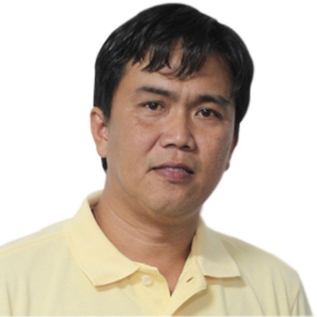
Certified By:

HON. YDAYLE N. DEL ROSARIO
Barangay Captain

